CS585
Database Systems
Summer 2013
Exam I

Name: _____________________
Student ID: _________________

 | Maximum | Received
Problem 1 | 20
Problem 2 | 15
Problem 3 | 15
Problem 4 | 15
Problem 5 | 10
Problem 6 | 15
Problem 7 | 10
Total | 100

1hr 50 minute exam. One 8.5X11 cheat sheet allowed.

- 20 pts
Indicate whether each of the following statements is true or false (T/F):

______Views can only be used to read data from the database but not write to it

______ER diagram is not useful when designing an object relational database.
______ Candidate key is a minimal superkey that uniquely identifies an entity.

______ If we compare two null values using <, >, =, and so on, the result is always
true.

______ Triggers are useful tools to maintain data integrity

______ Any ternary relationship can be reduced to two or three binary
relationships

______ Stored procedures can provide logical data independence

______ JDBC drivers are DBMS independent

______ View is a mechanism that provides support for physical data
independence

______Code written in SQLJ is platform independent

- 15 pts
Reduce the given EER diagram to relations using pure relational model (i.e., No Object Oriented or Object Relational). Be sure to identify all integrity constraints.

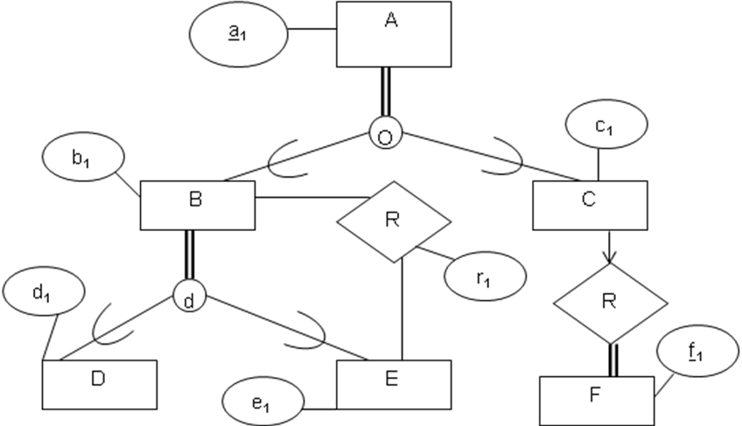

- 15 pts
Consider the relational conceptual database schema below for keeping track of course registration of students:

COURSES (Code, Title, Dept)
Registered (Code, SSN)
STUDENTS (SSN, Name, Dept, GPA)

(a) Retrieve the name of each student who registered for the course titled “Database Systems”.

(b) Retrieve the title of each course along with the number of students who registered for this course in descending order of registered student numbers.

(c) Retrieve the name of student(s) who have earned maximum GPA in every department that provides more than 30 courses.

- 15 pts

Consider the following relational schema:
Emp (eid: integer, ename: string, age: integer, salary: real)
Works (eid: integer, did: integer)
Dept (did: integer, dname:, managerid: integer)

Write SQL code to create tables for Emp, Works, Dept such that Works has two foreign keys referring to Emp (eid) and Dept (did) respectively, and Dept has a foreign key (managerid) referring to Emp respectively. In addition, when a Dept tuple is deleted, all Works tuples referring to it should be deleted. When an Emp tuple is deleted, for all Dept tuples referring to it, the managerid should be set to null. Note eid is primary key for Emp, and eid and did together are primary key for Works. And did is the primary key for Dept.

- 10 pts
Consider the six Tram Stations shown in the following picture of USC campus.
- Build a PR Quadtree for these six points. (You do not need to draw the actual tree, just show the partitioning on the above figure)
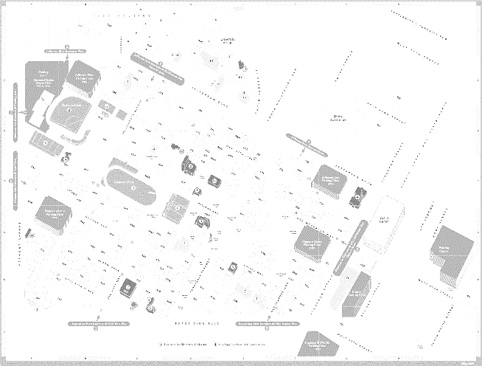
S1
S2
S5
S6
S3
S4

- A Tram starts from the first station which is S1 and after passing through all the stations stops at the last one which is S3. Construct a PM1 Quadtree for this path on the figure below.
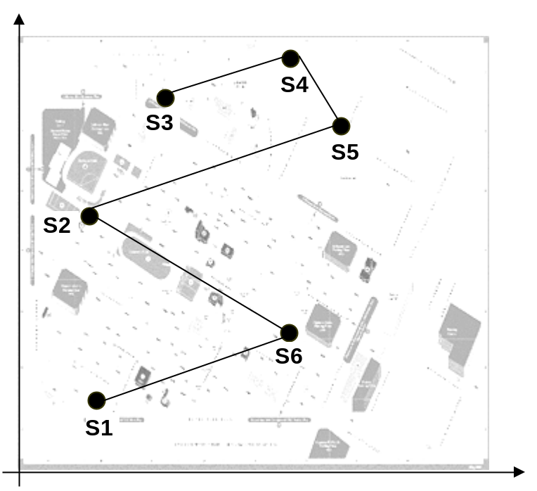
- 15 pts
A road network is maintained in a spatial database as following:

Road ID | Road Segment
L1 | (4, 7), (6, 8)
L2 | (6,4), (7, 7)
L3 | (2,1), (3, 2)
L4 | (0, 2), (1, 5)
L5 | (3, 3), (5, 6)

Assume that the roads are inserted in to the table with the ascending order of
RoadID (i.e., L1, L2, L3, L4, L5). Also assume that (m,M)=(2,4).

Draw the R-Tree index generated for the above table after each insertion.
In other words, you should draw five R-Trees. Use “Quadratic” method to
split the R-Tree Nodes. You need to briefly describe what happens after each
step. If you need to split a node, you should clearly and completely describe
which line(s) you select to become the first element of each child node, and
then which lines are added to each child node and why. You could use the
following chart to draw the lines.

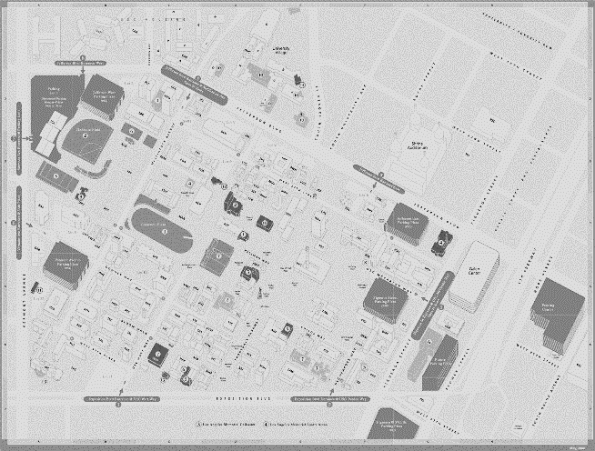
1234567
L1

L2

L4
L5

L3

- 10 pts
List two pros and two cons of each of the following database models: RDBMS, OODBMS and ORDBMS.
- RDBMS pros

- RDBMS cons

- OODBMS Pros

- OODBMS Cons

- ORDBMS Pros

- ORDBMS Cons

